FAT BEAM LASER BAR
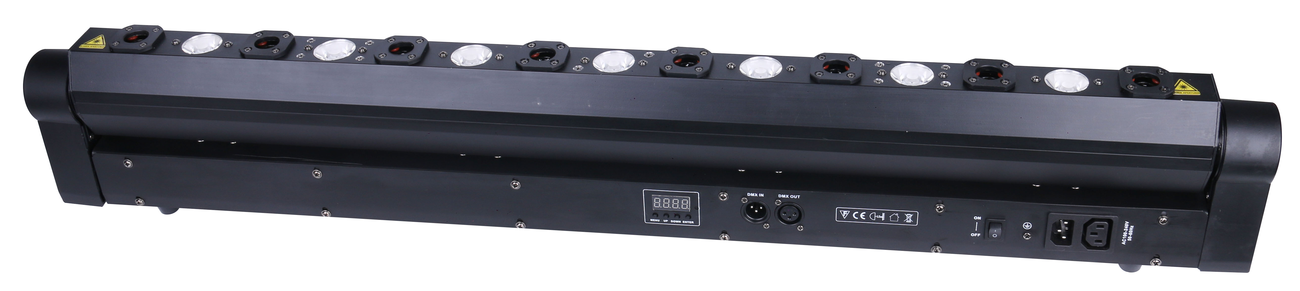

Please read this manual carefully before use!

Contents

Introduction and caution-------------------------------------------------------- P2

Safety instruction and product specification --------------------------- P3

Display menu operation & function------------------------------------------P5

DMX512 channel table----------------------------------------------------------P6-7

DMX connection and address setting---------------------------------------P7

Rigging and maintance-----------------------------------------------------------P9

Introduction
Thank you for your patronage. We are confident that our excellent products and service can satisfy you. For your own safety, please read this user manual carefully before installing the device.
In order to install , operate, and maintain the lighting safety and correctly. We suggest that the installation and operation should be done by the verified technician and follow the instruction strictly.

Following spare parts are included with the fixture:
- One quick lock handle
- One use manual
- One power cable
- One DMX signal cable
Caution
Before leaving the factory, this device has passed strict inspection, functions stable and perfect packing. If this device will be operated in any way different to the one described in this manual, the product may suffer damages and the guarantee becomes void. Furthermore, any other operation may lead to dangers like short circuit, burns, electric shock, crash etc. If any technology changes of this manual, company do not notice in further and have interpretation.



CAUTION!

Keep this device away from rain and moisture!

Unplug mains lead before opening the housing!


Warning!

Damages caused by the disregard of this user manual are not subject to warranty. The dealer will not accept liability for any resulting defects or problems.

- Safety Instructions
- Please open and check whether break or not for transport once receive this fixture, if yes, don ‘t use it and contact dealer or manufacture as soon as possible.
- This is a 3B laser product, only professional technicians are allowed to install and operate it.
- The Max applicable temperature for the light is 40°C. Do not use the light when the ambient temperature exceeds 40 degrees, ta=40℃
- The fixture is applicable for many occasions, please keep it clean, and avoid long use in overheating, wet or dusty environment. To prevent the fixture from the chemical liquid .
- User must be careful of fire, heat, electric and fall-off that make heavy or fatal injury. Please read this user manual carefully before power on and installation, follow safety and operation instruction in it. If still have any question, please contact dealer or manufacture.
- User must follow this user manual, do not open fixture by yourself, if any problem, please contact professional technician, maintenance should be done by technician.
- Do not turn on the fixture before installation, please turn off the light after working more than 8 hours, which will prolong the lifespan of the fixture.
- During installation, prevent strong shocks or do not by strong shocks or vibration.
- The minimum distance between light and the illuminated surface must be more than 1 meter. 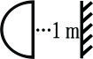

- Never look directly into the light source to avoid hurt to eyes (especially epileptics)!
- When dust proof glass at light output breaks, cracks or other visible damage, user should replace with new glass instead.
- To protect the laser light, after 5 hours working, please turn it off for 5 minutes at least to cool the laser down, then turn it on again.

2. Installation
► This fixture is not suitable for direct installation on combustible material surface, please keep the fixture surface at least 0.5m from any combustible material.

► If you use the quick lock cam in hanging up the fixture, please make sure the quick lock fasteners turned in the quick lock holes correctly.
►The truss for hanging the fixture should be able to hold 10 times weight of this fixture and no deformation after 1 hour hang.
►Please don’t stand under the fixture when install, uninstall, move or repair the fixture.
►Please ensure the light is connected correctly and invite professional technician to check and confirm the electrical data before installation.
►Please invite professional technician to check the fixture and installation each year.

3、Product specifications
- Input voltage:AC100V~240V 50/60Hz
- Fuse: 250VAC 2A
- Power consumption:68W
- Control mode: auto/sound/DMX512/Master-slave
- DMX channels: 7/22CH
- Scanning：step motor
- LED: 7pcs 3W amber LED with average lifespan 50000hours and color temperature 2200K, beam angle 7º
- Laser diode:8pcs red laser diode, with separate diode control
- TILT: 180º
- Working temperature:10℃~40℃
- 0-100% dimming
- 0-25Hz strobe
- Product dimension: 1000*84*173mm, net weight: 6.8KG

4. LED digit display menu:
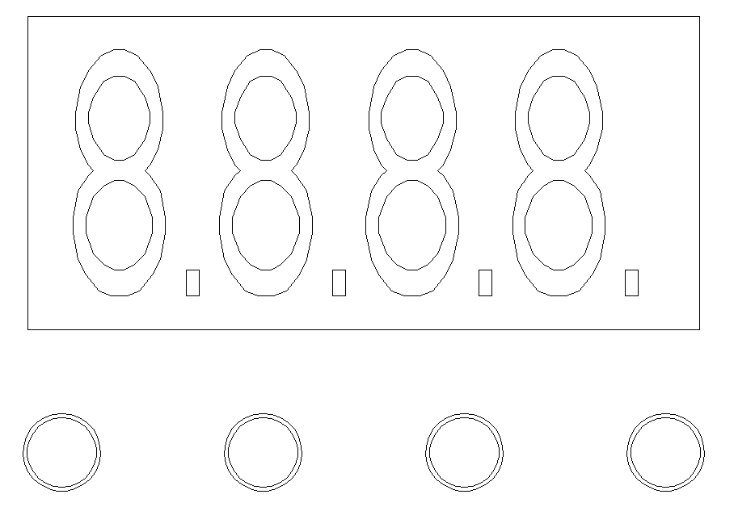
A: MENU

B: DOWN

C: UP

D: ENTER

A B C D

Press MENU to choose Address / DMX/ Color/ Manual/ Demo /Auto/Sound/ Temp /Version /Hours, then press ENTER to confirm or to enter the next step.if there are more function for options, press UP/DOWN to choose, then press ENTER to confirm, then press MENU to exit, or wait for 10 and exit automatically.

Remarks: if no any operation on any button, the display will turn off automatically in 20seconds; if no DMX signal, the first dot of the display will turn on statically, if with DMX signal, the dot will flash.

5. LED display Function Instruction
NO | Display |  |  | Functions
1 | Addr | A001-A512 |  | DMX512
2 | Chnd | CH22 |  | 22CH
 |  | CH07 |  | 7CH
3 | Slnd | HoSt |  | master
3 | Slnd | SLAV |  | slave
4 | LoSt | AUTO | AU01-AU02 | auto
4 | LoSt | BLAC |  | black
4 | LoSt | HOLD |  | hold
4 | LoSt | SOUN |  | sound
5 | SEnS | S001-S100 | 70 | sound sensitivity
6 | Inv | ON |  | light reverse
6 | Inv | OFF |  | Light reverse OFF
7 | Corr | 0-255 | 127 | Tilt fine
8 | DISP | rdon |  | display forward direction
8 | DISP | rdoF |  | display reverse
9 | LED | ON |  | display ON
9 | LED | OFF |  | display off after 13seconds
10 | Deft | YES |  | factory default
11 | Rest | YES |  | system reset
12 | u1.00 | u1.00 |  | software version

6.DMX table
22 DMX channels
CH# | Display | Value | Function
CH1 | Master dimmer | 0-255 | Dimmer 0-100%
CH2 | strobe | 000-015 | No Function (open)
CH2 | strobe | 016-095 | Strobe （1HZ-25HZ Slow-Fast）
CH2 | strobe | 096-175 | Strobe （1HZ Slow-Fast）
CH2 | strobe | 176-255 | Random Strobe
CH3 | Motor position | 0-255 | Motor position
CH4 | Motor fine | 0-255 | Motor fine
CH5 | Motor speed | 0-255 | Motor speed
CH6 | laser+led chasing effect | 0-15 | OFF
CH6 | laser+led chasing effect | 16-35 | effect 1
CH6 | laser+led chasing effect | 36-55 | effect 2
CH6 | laser+led chasing effect | 56-75 | effect 3
CH6 | laser+led chasing effect | 76-95 | effect 4
CH6 | laser+led chasing effect | 96-115 | effect 5
CH6 | laser+led chasing effect | 116-135 | effect 6
CH6 | laser+led chasing effect | 136-155 | effect 7
CH6 | laser+led chasing effect | 156-175 | effect 8
CH6 | laser+led chasing effect | 176-195 | effect 9
CH6 | laser+led chasing effect | 196-255 | effect 10
CH7 | chasing speed | 0-255 | slow to fast
CH8 | laser 1 | 0-127 | OFF
CH8 | laser 1 | 128-255 | ON
CH9 | laser 2 | 0-127 | OFF
CH9 | laser 2 | 128-255 | ON
CH10 | laser 3 | 0-127 | OFF
CH10 | laser 3 | 128-255 | ON
CH11 | laser 4 | 0-127 | OFF
CH11 | laser 4 | 128-255 | ON
CH12 | laser 5 | 0-127 | OFF
CH12 | laser 5 | 128-255 | ON
CH13 | laser 6 | 0-127 | OFF
CH13 | laser 6 | 128-255 | ON
CH14 | laser 7 | 0-127 | OFF
CH14 | laser 7 | 128-255 | ON
CH15 | laser 8 | 0-127 | OFF
CH15 | laser 8 | 128-255 | ON
CH16 | LED1 | 0-255 | dimmer 0-100%
CH17 | LED2 | 0-255 | dimmer 0-100%
CH18 | LED3 | 0-255 | Dimmer 0-100%
CH19 | LED4 | 0-255 | Dimmer 0-100%
CH20 | LED5 | 0-255 | Dimmer 0-100%
CH21 | LED6 | 0-255 | Dimmer 0-100%
CH22 | LED7 | 0-255 | dimmer 0-100%

7DMX channels
CH# | Display | Value | Function
CH1 | master dimmer | 0-255 | dimmer 0-100%
CH2 | strobe | 000-015 | No Function (open)
CH2 | strobe | 016-095 | Strobe （1HZ-25HZ Slow-Fast）
CH2 | strobe | 096-175 | Strobe （1HZ Slow-Fast）
CH2 | strobe | 176-255 | Random Strobe
CH3 | motor position | 0-255 | motor position
CH4 | motor fine | 0-255 | motor fine
CH5 | motor speed | 0-255 | motor speed
CH6 | laser+led | 000-29 | OFF
CH6 | laser+led | 30-99 | LASER ON
CH6 | laser+led | 100-199 | LED ON
CH6 | laser+led | 200-255 | LASER+LED ON
CH7 | auto | 000-30 | OFF
CH7 | auto | 31-200 | AUTO MODE
CH7 | auto | 201-255 | SOUND MODE

7. DMX-512 control connection

Connect the provided XLR cable to the male 3-pin XLR output of your controller and the other side to the female 3-pin XLR input of the light.You can chain multiple lights together through serial linking, the signal cable should have two core with shielded cable, the signal connectors are with XLR input and output connectors. Please refer to the below diagram:

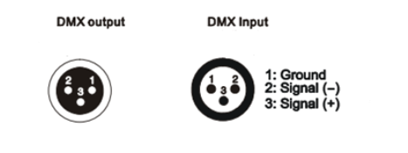
8. DMX address setting
Each fixture must set a specific starting address. When receiving signal, fixture will receive channel control signals of this address from the DMX controller.
For easy to use, the user can set the same address for several fixtures , also can set up a unique address for every device.
If you set the same address for all fixtures, all the fixtures will receive from the same DMX channels signal. All connecting fixtures are jointly controlled, controller can't separate control a device.
If you set a different address for each fixture, each fixture will receive unique signal and can be controlled by DMX controller separately.
This fixture has 22 channels.you should set the starting address of the first unit to 1, the second unit to 23(1*22 + 1), the third unit to 45(2*22+ 1), and so on.
For master/slave mode, the master unit be set as Auto or Sound, and slave unit is set as D001, only 1 master unit for each group.

DMX-512 connection with DMX terminator
If there are many lines or lights, it is recommended to use a DMX terminator to prevent DMX signal corruption, the DMX terminator is an simple XLR plug with a 120 Ω resistor connected between pins 2 and 3,which is then plugged into the output XLR socket of the last fixture in the chain.
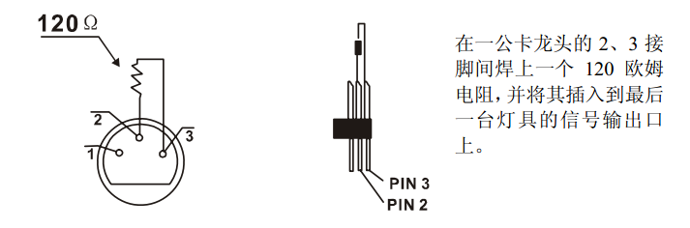
Welding a 120 ohm resistor between 2 and 3 pins male XLR , and insert it into the signal output of the last device

8. Rigging:
►The applicable temperature for the fixture is between -25°C to 45°C. Do not use the lighting under or above this temperature range.
►The truss for hanging the fixture should be able to hold 10 times weight of this fixture and no deformation after 1 hour hang.
►Please don’t stand under the fixture when install, uninstall, move or repair the fixture.
►Please ensure the light is connected correctly and invite professional technician to check and confirm the electrical data before installation.
►Please invite professional technician to check the fixture and installation each year.

9. Cleaning and maintenance

Cleaning should be performed every 15-day period, by using a sponge which is dipped with alcohol, rather than wet cloth or other chemical liquid, to clean the mirror.

Cut off power before cleaning and maintenance!
CAUTION

Attention

Do not see directly light source when open the light, and make sure power off before do any installation or maintenance.

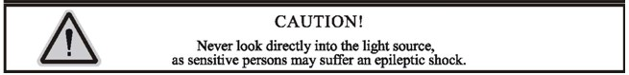

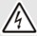 Wires connection must be done professional person!
CAUTION

